Chapter 5: Introduction to Valuation: The Time Value of Money

- Simple Interest versus Compound Interest: First City Bank pays 8 percent simple interest on its savings account balances, whereas Second City Bank pays 8 percent interest compounded annually. If you made a $5,000 deposit in each bank, how much more money would you earn from your Second City Bank account at the end of 10 years?

Your First City Bank account is simple interest; therefore, your annual interest earned per year is:

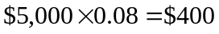

At the end of 10 years, your First City Bank account would have earned a total amount of interest of:

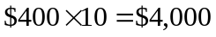

Therefore, your First City Bank account would have a balance of:

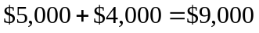

Your Second City Bank account pays compound interest (compounded on an annual basis); therefore, your balance at the end of 10 years using the formula would be:

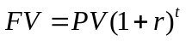

Your Second City Bank account balance at the end of 10 years using a financial calculator would be:

Your Second City Bank account would have an additional $1,794.63 in it at the end of 10 years compared to your First City Bank account:

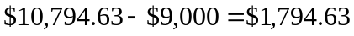

- Calculating Future Values: For each of the following, compute the future value:

Present Value Years Interest Rate
$2,250 11 10%

To find the future value of a lump sum, we use the following equation:

Using a financial calculator:

Present Value Years Interest Rate
$8,752 7 8%

To find the future value of a lump sum, we use the following equation:

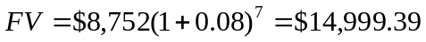

Using a financial calculator:

Present Value Years Interest Rate
$76,355 14 17%

To find the future value of a lump sum, we use the following equation:

Using a financial calculator:

Present Value Years Interest Rate
$183,796 8 7%

To find the future value of a lump sum, we use the following equation:

Using a financial calculator:

- Calculating Present Values: For each of the following, compute the present value:

Future Value Years Interest Rate
$15,451 6 7%

To find the present value of a lump sum, we use the following equation:

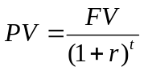

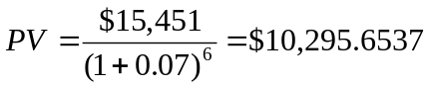

Using a financial calculator:

Future Value Years Interest Rate
$51,557 7 13%

To find the present value of a lump sum, we use the following equation:

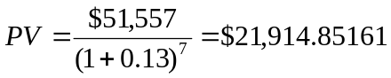

Using a financial calculator:

Future Value Years Interest Rate
$886,073 23 14%

To find the present value of a lump sum, we use the following equation:

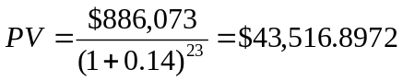

Using a financial calculator:

Future Value Years Interest Rate
$550,164 18 9%

To find the present value of a lump sum, we use the following equation:

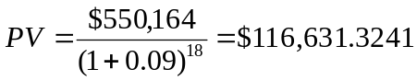

Using a financial calculator:

- Calculating Interest Rates: Assume the total cost of a college education will be $290,000 when your child enters college in 18 years. You presently have $55,000 to invest. What annual rate of interest must you earn on your investment to cover the cost of your child’s college education?

We can use either the PV or FV equation to solve for the required rate of return:

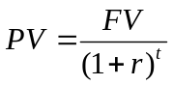 or

Solving for r:

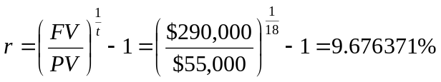

Using a financial calculator:

- Calculating Present Value: Imprudential, Inc., has an unfunded pension liability of $650 million that must be paid in 20 years. To assess the value of the firm’s stock, financial analysts want to discount this liability back to the present. If the relevant discount rate is 7.4 percent, what is the present value of this liability?

To find the present value of a lump sum, we use the following equation:

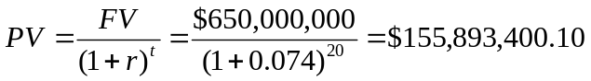

Using a financial calculator:

18. Calculating Future Values: You have just made your first $4,000 contribution to your individual retirement account. Assuming you earn a 11 percent rate of return and make no additional contributions, what will your account be worth when you retire in 45 years? What if you wait 10 years before contributing? (Does this suggest an investment strategy?!)

To find the future value of a lump sum, we use the following equation:

Using a financial calculator:

If you wait 10 years before making the $4,000 investment, your value at retirement will be:

Using a financial calculator:

If you wait 10 years you lose $283,821.56! This is the “magic” of compounding!! You had better start early.

- Calculating Future Values: You are scheduled to receive $20,000 in two years. When you receive it, you will invest it for six more years at 8.4 percent per year. How much will you have in eight years?

To find the future value of a lump sum, we use the following equation:

Using a financial calculator:

